Minutes for the Regular Monthly Meeting
Tuesday, April 28, 2015, at the Florida Avenue Baptist Church

Call to order at 7:08 pm
- Introduction by President Golda Philip: participants take 5 minutes to introduce themselves to at least one person they don’t know.
- Public Safety (7:12-7:20pm)
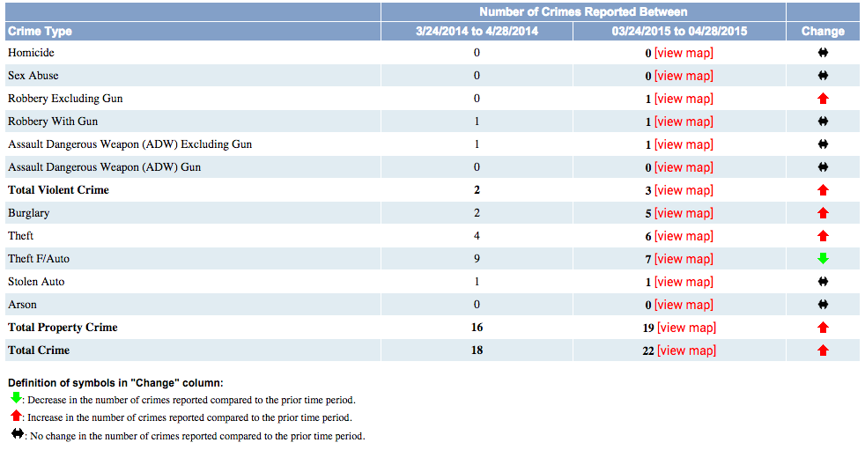
  - Crime in LeDroit Park between March and April

- Nominations Committee (7:20-7:22pm) will be led by Richard Myers, Parliamentarian, and is tasked with recruiting members to run for Executive Board positions for the next year. Please email Richard at richardmyers@verizon.net if you are interested in assisting or running for: President, Vice President, Secretary, or Treasurer.
- Community Presentations
  - McMillan Update by Zeba Floyd (7:22-7:48pm) – please see attached presentation. If you have any questions please contact Zeba at ______________.
  - DC Property Tax Relief by Alex DeLorme (7:48-7:55pm) – see attached information from the Office of Tax and Revenue. For more information go to http://otr.cfo.dc.gov or contact Alex at alex@itsyourabode.com or 202-250-0021.
  - Targeted Incentives Program for Homeowners by Andi Oetman (7:55-8:05pm) – see attached for details about the program. Schedule the District Department of the Environment (DDOE) to come out to your property to perform an analysis of what changes you can make by filling out an application at http://ddoe.dc.gov/service/riversmart-homes-application

- Committee Reports
  - Parks Committee Report by Christy Henry (8:05-8:10)
    - The April 26 Dig at LeDroit Event at the Park was a huge success. Special thanks to community partners for all their assistance.
      - Common Good City Farm https://www.facebook.com/CommonGoodCityFarm?fref=ts
      - LeDroit Park Community Garden https://www.facebook.com/LeDroitParkCommunityGarden?fref=ts
      - Friends of Bloomingdales/ LeDroit Park Dogs https://www.facebook.com/BLDPA?fref=ts
      - MPD: https://www.facebook.com/DCPolice?fref=ts&rf=110625165626020
      - All Souls: https://www.facebook.com/allsoulsbar?fref=ts
      - Aroi Thai: https://www.facebook.com/AroiThaiDC?fref=ts
      - Bacio: https://www.facebook.com/BacioPizzeria?fref=ts
      - Big Bear Café https://www.facebook.com/BigBearCafeDC?fref=ts
      - Boundary Stone https://www.facebook.com/BoundaryStoneDC?fref=ts
      - Grassroots Gourmet https://www.facebook.com/GrassrootsGourmet?fref=ts
      - Right Proper Brewing https://www.facebook.com/RightProperBrewingCompany?fref=ts
      - Rito Loco: https://www.facebook.com/ritoloco?fref=ts
      - The Royal/ Vinoteca https://www.facebook.com/DCVinoteca?fref=ts
      - Uprising Muffin https://www.facebook.com/UprisingMuffins?fref=ts
      - ServeDC for helping recruit volunteers:
https://www.facebook.com/IServeDC
    - Check out the LPCA website for pictures of event.
    - Thanks to CommonGood City Farm for their flower donation to fill the tree boxes lining on U Street between 4th and 2nd.
    - Committee is requesting weekly help watering the trees planted last year. Will be out every Wednesday at 6:30pm. If you are interested in helping or have any questions please email treeatledroit@gmail.com
  - LeDroit Park Transportation Package Presentation by ANC Commissioner Brian Footer (8:10-8:40pm) – see attached for final version of package
    - Motions for amendments:
      - Motion to keep 2 hour parking zones as is and expand enforcement of residential only permit parking to Monday-Sunday from 7am to Midnight.
        - Motion by Prof. Hill and seconded by Ashley Jefferson
        - Motion passed with 1 nah and 2 abstentions
      - Motion to support transportation package with 9 recommendations
        - Motion by Ashley Jefferson and seconded by Tipton
        - Motion passed unanimously
    - Recommendations removed to obtain more information and report back at next general meeting:
      - Reduce the amount of unnecessary restricted space around Metro Bus stops.
      - Designate the Elm Street parking lot spaces as zone 1 only parking.
    - Questions:
      - Process of petition for rezoning enforcement on blocks: DDOT is looking into whether petitions with 80% of block signatures will be necessary due to the community involvement and comprehensive nature of package.
      - Zipcar permits: Zipcar has zone 9 permits allowing them to park in any residential permit parking zone in the city.
      - How would changing all the enforcement of zone parking impact guests ability to visit: after public discussion of the pros and cons of limiting weekend parking, a compromise was reached in that the 2 hour enforcement zones, which consist of just under 50% of all parking in LeDroit, would remain the same and just the zone only parking areas would expand enforcement.
      - How would stop sign at 4th and U impact traffic: DDOT would come out to do a survey study.
  - For more information or questions regarding the transportation package please contact Brian at 1B01@anc.dc.gov

The meeting adjourned at 8:40 pm.

This memorandum represents our understanding of the events that transpired and the actions that were taken. If they do not conform to a recipient’s understand, prompt written notice must be communicated to the writer. If no corrections or objections are made, this memorandum will be relied upon as a factual interpretation of this meeting.

Submitted on Sunday, May 3, 2015, by Brian Footer, Secretary of the LeDroit Park Civic Association.

OFFICE OF TAX AND REVENUE – Real Property Tax Relief

Homestead Deduction and Senior Citizen or Disabled Property Owner Tax Relief:
This benefit reduces your real property's assessed value by $71,400 prior to computing the yearly tax liability.
The Homestead benefit is limited to residential property. To qualify:
- An application must be on file with the Office of Tax and Revenue;
- The property must be occupied by the owner/applicant and contain no more than five dwelling units (including the unit occupied by the owner); and
- The property must be the principal residence (domicile) of the owner/applicant.
If a properly completed and approved application is filed from October 1 to March 31, the property will receive the Homestead benefit for the entire tax year (and for all tax years in the future). If a properly completed and approved application is filed from April 1 to September 30, the property will receive one-half of the benefit reflected on the second-half tax bill (and full deductions for all tax years in the future).

Senior Citizen or Disabled Property Owner Tax Relief
When a property owner turns 65 years of age or older, or when he or she is disabled, he or she may file an application immediately for disabled or senior citizen property tax relief. This benefit reduces a qualified property owner's property tax by 50 percent. If the property owner lives in a cooperative housing association, the cooperative will supply and collect the applications. The following guidelines apply:
- The disabled or senior citizen must own 50 percent or more of the property or cooperative unit;
- The total federal adjusted gross income of everyone living in the property or cooperative unit, excluding tenants, must be less than $127,100 for the prior calendar year; and
- The same requirements for application, occupancy, ownership, principal residence (domicile), number of dwelling units, cooperative housing associations and revocable trusts apply as in the homestead deduction.

Tax Deferral For Low-Income Senior Property Owners And Low-Income Property Owners
Effective October 1, 2014, low-income seniors may defer real property taxes, past due and prospective, at either 6% interest or no interest, depending upon age, income and length of residency. OTR has devised a form with which the senior must apply.

RiverSmart Homes Defined
This District-wide program offers incentives to homeowners interested in reducing stormwater runoff from their properties. Homeowners receive up to $1,200 to adopt one or more of the following landscape enhancements:
- Shade Tree Planting
- Rain Barrels
- Pervious Pavers
- Rain Gardens
- BayScaping

Benefits of RiverSmart Homes to the Homeowner
RiverSmart Homes landscaping enhancements can provide numerous benefits to homeowners, such as:
- Beautifully landscaped properties
- Cost savings on water, electricity
- and lawn-mower fuel and oil
- Reduced heating and cooling bills
- Less time devoted to lawn-care,
- resulting in extra time to relax
- Reduced stress and better health
- Higher property values.

Benefits of RiverSmart Homes to the District
New development and large renovations of properties in the District are required to have items that reduce stormwater runoff. Unfortunately, most of the District was built before modern methods for controlling and treating stormwater were developed. Chances are you do not have any stormwater control measures on your property.
RiverSmart Homes provides incentives to beautify your property and benefit the District’s environment by:
- Minimizing the use of herbicides, pesticides and fertilizers used in conventional landscaping
- Stabilizing soils, helping to prevent erosion
- Providing increased habitat for native wildlife
- Reducing air pollution and the urban heat island effect
- Treating and infiltrating stormwater on site helping to recharge groundwater levels
- Diminishing the impact on aquatic life from polluted stormwater rushing to local streams during storm events.

How to Become a RiverSmart Homeowner
Schedule the District Department of the Environment (DDOE) to come out to your property to perform an analysis of what changes you can make by filling out an application at http://ddoe.dc.gov/service/riversmart-homes-application

